1st Grade The President Inquiry
Is the President the Most Important Person in Government?
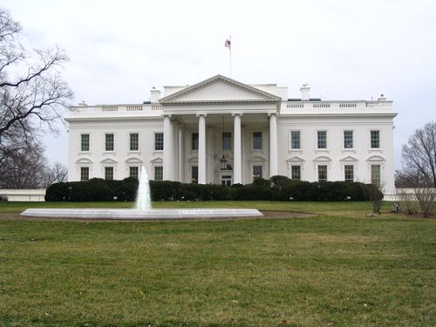

[Cover Photo Needed]
© 2015 ReadWorks®, Inc. All rights reserved.

Supporting Questions
- What does the president do?
- What do other leaders do?
- Can the president solve every problem?

1st Grade The President Inquiry

Is the President the Most Important Person in Government?
New York State Social Studies Framework Key Idea & Practices | 1.4: People create governments in order to create peace and establish order. Laws are created to protect the rights and define the responsibilities of individuals and groups.  Gathering, Using, and Interpreting Evidence Civic Participation
Staging the Question | Brainstorm problems in the school or neighborhood that students would like to see fixed.

Supporting Question 1 |  | Supporting Question 2 |  | Supporting Question 3
What does the president do? |  | What do other leaders do? |  | Can the president solve every problem?
Formative  Performance Task |  | Formative  Performance Task |  | Formative  Performance Task
Create a poster illustrating the main jobs of the president in writing and drawings. |  | Complete a graphic organizer listing local and state leadership positions with examples of duties. |  | Write a claim that answers the question with evidence from the sources.
Featured Sources |  | Featured Sources |  | Featured Sources
Source A: ”The Three Branches of Government”  Source B: “President of the United States”  Source C: What Does the President Do? |  | Source A: “Important People” |  | Source A: “Recovering and Rebuilding after Hurricane Sandy”  Source B: Excerpt from “Governor Cuomo Announces $8.2 Million Grant for ‘Project Hope’ to Provide Crisis Counseling in Areas Hardest Hit by Hurricane Sandy”  Source C: Press conference with Mayor Bloomberg, Rebuilding after Hurricane Sandy

Summative Performance Task | ARGUMENT Is the president the most important person in government? Construct an argument that addresses the compelling question using specific claims and evidence from sources.
 | EXTENSION Write letters to parents that explain how students used to think about the role of president and how they think about it now.
Taking Informed Action | UNDERSTAND Return to the list of problems from the Staging the Compelling Question activity and make a class chart showing who is responsible for addressing each issue.  ASSESS Choose one of the problems that the class would like to pursue.  ACT Contact a local, state, or national official whose responsibilities include the problem the class decides to pursue.

Overview

Inquiry Description
This inquiry engages first graders in exploring the meaning and purpose and function of government through the compelling question “Is the president the most important person in government?” Assuming that most first graders know who the president is, this inquiry is designed to help students explore the different levels of governmental leadership and the idea that other authority figures exist in addition to the president. In learning about the levels of government and the issues each deals with, students should consider their own ideas for desired change within their communities (e.g., more recreational space, better roads, more variety in school lunches) and develop a commitment to civic participation.
NOTE: Some of the sources in this inquiry draw on events around Hurricane Sandy. Teachers should exercise their judgment and discretion and, if they deem it appropriate, substitute sources of a similar nature.
In addition to the Key Idea listed earlier, this inquiry highlights the following Conceptual Understanding:
- (1.4b) Governments exist at the local, state, and national levels to represent the needs of the people, create and enforce laws, and help resolve conflicts.
NOTE: This inquiry is expected to take three to five 30-minute class periods. The inquiry time frame could expand if teachers think their students need additional instructional experiences (i.e., supporting questions, formative performance tasks, and featured sources). Teachers are encouraged to adapt the inquiries to meet the needs and interests of their particular students. Resources can also be modified as necessary to meet individualized education programs (IEPs) or Section 504 Plans for students with disabilities.

Structure of the Inquiry
In addressing the compelling question “Is the president the most important person in government?” students work through a series of supporting questions, formative performance tasks, and featured sources in order to construct an argument with evidence from a variety of sources.

Staging the Compelling Question
To launch this inquiry, teachers should share the compelling question with the class and encourage students to brainstorm about what they think the president of the United States actually does. Students are likely to have many ideas about this question, though they may think largely in terms of being “in charge.” Afterward, teachers can ask students to create a class list of topics or problems that they would like to see fixed in their school, neighborhoods, or community. (All answers can be accepted at this point as they should lend themselves to the Extension and Taking Informed Action pieces of the inquiry.)

Supporting Question 1
The first supporting question—“What does the president do?”—initiates the idea that government is the system of rules and leaders created for our country to represent the needs of many people, to create and enforce laws, and to help resolve conflicts. The formative performance task asks students to focus on a governmental role with which they should have some familiarity—the United States president—by creating a poster that depicts four or five of the duties that the president assumes. Featured Source A, a read-aloud article describing the three branches of government, is useful so that students can see some of the other government leaders in Washington, DC. Featured Source B and C highlight the role and duties of the president.

Supporting Question 2
The second supporting question—“What do other leaders do?”—requires students to examine how government functions on different levels (national, state, and local). Students learn that these levels exist in order to better serve the range of citizens’ needs. The formative performance task asks students to complete a graphic organizer listing local and state leadership positions with examples of the assigned duties. Featured Source A presents the idea that there are leaders at all levels of society, from the school to the nation.

Supporting Question 3
The third supporting question—“Can the president solve every problem?”—calls upon students to integrate and apply the information from the previous tasks in the context of a real-life event: Hurricane Sandy. The formative performance task asks students to synthesize the information in the sources into an evidence-based claim that responds to the supporting question. Featured Sources A and C are short videos featuring, respectively, President Barack Obama and Mayor Michael Bloomberg talking about the actions they took in the aftermath of Hurricane Sandy. Featured Source B is a read-aloud piece from Governor Cuomo’s website announcing a new relief program.

Summative Performance Task
At this point in the inquiry students have looked at the duties of leaders at the national, state, and local levels and have seen how those leaders responded to a natural disaster. Students draw upon understandings developed through the formative performance tasks to craft arguments stemming from the compelling question and supported with evidence drawn from the sources. Their arguments can be presented through written expression or a combination of drawing and writing. To prepare for crafting their arguments, students may gather their sources and notes and discuss in small groups the relationship between the supporting questions/featured sources and the compelling question.
Student arguments will likely vary, but could include any of the following:
- The president is the most important person in government because he or she is the one in charge of the whole country.
- The president is not the most important person in government because he or she doesn’t have any more power than any other leader.
- The president shares power with other leaders in the government, like governors and the city council, so all government leaders are important.
Students could extend these arguments by writing letters to their parents in which they explain how they used to think about the role of president and how they think about it now.
Students have the opportunity to Take Informed Action by drawing on their knowledge of the structure and purpose of local, state, and national government leaders. They demonstrate that they understand by returning to the list of problems from the Staging the Compelling Question activity and making a class chart showing who is responsible for addressing each issue. They show their ability to assess by choosing an issue or problem that they would like to see addressed. And they act by contacting a governmental official whose jurisdiction is relevant.

Supporting Question 1
Featured Source | Source A: Susan LaBella, article describing the branches of government at the national level, “The Three Branches of Government,” 2015

The Three Branches of Government

By Susan LaBella
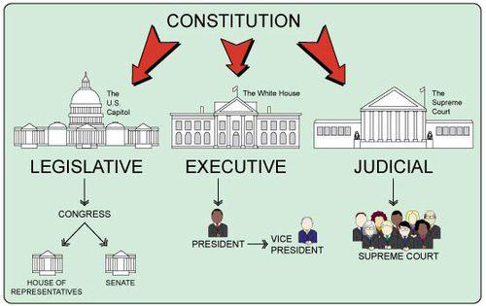
The United States Constitution was written over two hundred years ago. It explains how the country’s government should work. The people who wrote the Constitution did not want one person or group to have too much power. That was why they divided the government into three parts, known as branches.

The branches are the legislative, the executive, and the judicial. Each branch has its own responsibilities. Any branch can change decisions made by the other two branches.

The legislative branch is called the United States Congress. It is made up of the House of Representatives and the Senate. Voters in each state elect their U.S. representatives and senators. Those men and women go to Washington, D.C., to pass laws.

The executive branch has the power to carry out the laws. It includes the president, the vice president, and their group of advisers called the cabinet. Every four years, Americans vote to elect a president and a vice president.

The judicial branch makes sure laws are written and followed correctly. This branch includes the United States Supreme Court. Nine justices serve on the Supreme Court. The president appoints the justices, and the Senate approves them. The justices’ job is to decide important questions about the country’s laws.

© 2015 ReadWorks®, Inc. All rights reserved. http://www.readworks.org/passages/three-branches-government.

Supporting Question 1
Featured Source | Source B: Susan LaBella, article describing the role of president, “President of the United States,” 2014
President of the United States
By Susan LaBella
Every four years, the people of the United States vote for the country’s leader. The winner of that election becomes the nation’s president.
The president may be a man or a woman. He or she will live and work in the White House in Washington, D.C. What does the president do? Here are some examples.
The president is the leader of the American government. The president suggests laws he or she thinks the country needs. The president may work with the members of the U.S. Congress to get those ideas turned into laws.
The president appoints people to help run the government. These people include judges and leaders of government departments. Often, the president’s choices have to be approved by the U.S. Congress.
The president is commander-in-chief of the country’s military. That means the president is responsible for the actions of the Army, Navy, Marine Corps, Air Force and Coast Guard.
During any one day, an American president can do many things. The president can speak with advisors, give a speech, or sign a bill into law. The president may meet with leaders of other countries. In the evening, the president sometimes attends special events.
Being president of the United States is a difficult, complicated job.
© 2014 ReadWorks®, Inc. All rights reserved. http://www.readworks.org/passages/president-united-states.

Supporting Question 1
Featured Source | Source C: Author unknown, Ebook describing the president’s duties, What Does the President Do? 2015

NOTE: The screen shot below is the first page of the Ebook on the presidency. Teachers and students can click on this link to listen to and read the text: http://teacher.scholastic.com/commclub/president_activity2/index.htm.

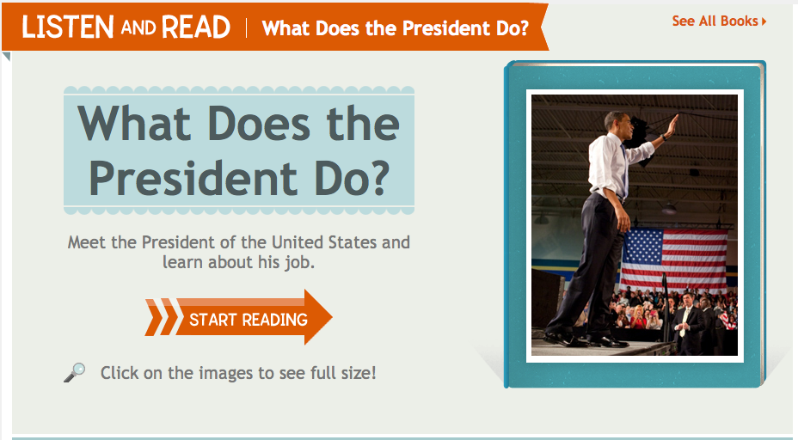

From LISTEN AND READ: WHAT DOES THE PRESIDENT DO? Published on teacher.scholastic.com. Copyright © 2015 by Scholastic Inc. Used by permission. http://teacher.scholastic.com/commclub/president_activity2/index.htm

Supporting Question 2
Featured Source | Source A: Michael Stahl, article about different levels of authority, “Important People,” 2013

Important People
By Michael Stahl

The janitor is the person who helps keep the school clean. Every morning students come from all over and walk into the school building. A building can get dirty, especially when a lot of people go into it. The janitor sweeps and mops the floors so that the dirt brought in gets cleaned up.
The teacher is the person who runs the classroom. The teacher helps you learn about different topics and gives you assignments. If you don’t understand something, you can ask the teacher for help.
The principal is the person who is in charge of the whole school. The principal is the leader of the school. The principal is in charge of all the teachers at the school. The principal is the person whom parents call when they want to talk to someone about the school. The principal usually sets high expectations for the students and makes sure that learning is happening in the school.
American schools are in a city or town. The city or town has a leader, too. The leader is usually called the mayor. The mayor is in charge of running the government of the city or town. The mayor works with the people in the city or town and the other people in the government to fix the problems of the city or town. The mayor has a lot of responsibility.
An American city or town is located within a state. Just like a city or town has a leader, a state has a leader too. The leader of a state is called the governor. An American state is a part of the United States. There are 50 states, and each one has a governor. The person who is the leader of the United States of America is called the president. There have been over forty presidents throughout the course of America’s history. The first president of the United States of America was George Washington. Who is the current president?
© 2013 ReadWorks®, Inc. All rights reserved. http://www.readworks.org/passages/important-people.

Supporting Question 3
Featured Source | Source A: Barack Obama, television address on Hurricane Sandy, “Recovering and Rebuilding after Hurricane Sandy,” 2012

NOTE: The screen shot below features President Obama addressing the aftermath of Hurricane Sandy and the national government’s efforts to help people.

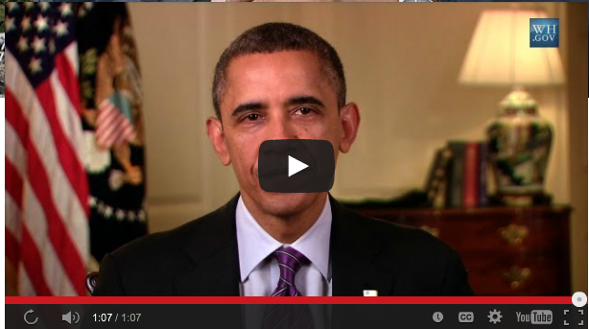

Public domain. The White House website: https://www.whitehouse.gov/issues/hurricane/sandy.

Supporting Question 3
Featured Source | Source B: Governor Andrew Cuomo, press release after Hurricane Sandy, “Governor Cuomo Announces $8.2 Million Grant for ‘Project Hope’ to Provide Crisis Counseling in Areas Hardest Hit by Hurricane Sandy” (excerpts), November 19, 2012

Governor Andrew M. Cuomo today announced an $8.2 million grant … called Project Hope for New Yorkers in the hardest hit areas of Hurricane Sandy. The State Office of Mental Health (OMH) applied for the grant which will provide outreach, crisis counseling and educational services to individuals in New York City, Long Island and the Lower Hudson Valley. As the state continues to recover from the storm, the program will receive additional funding to expand.…
Hurricane Sandy wreaked destruction on our buildings and roads but the impact was not only physical, Governor Cuomo said. The storm turned the lives of thousands of New Yorkers upside down, inflicting damage that was also emotional and mental. Project Hope will provide mental health support for New Yorkers in the hardest hit areas of the state, and I encourage those who may be experiencing trauma or simply need to talk to someone to call for help. I thank the federal government for their assistance.…
If you or someone you know is experiencing any of the above signs of trauma from Hurricane Sandy, please encourage them to get help immediately. The faster they get the help they need, the faster they can recover and rebuild their lives.
Public domain. New York State website: http://www.governor.ny.gov/news/governor-cuomo-announces-82-million-grant-project-hope-provide-crisis-counseling-areas-hardest.

Supporting Question 3
Featured Source | Source C: Mayor Michael Bloomberg, press conference after Hurricane Sandy, Mayor Bloomberg Updates New Yorkers on City’s Response to Hurricane Sandy, October 30, 2012

NOTE: The screen shot below is from a press conference that Mayor Michael Bloomberg held to describe the efforts he and his staff were making to help people after Hurricane Sandy. The relevant section is from 0:00-4:10.

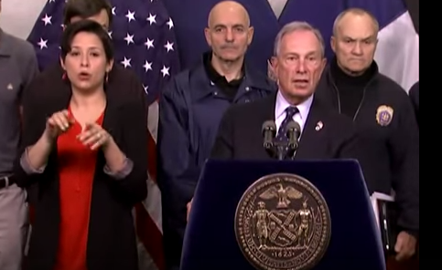

Public domain. Mayor Bloomberg YouTube channel: https://www.youtube.com/watch?v=ZpAp2MCecgM.

